Diffrence between Transit Gatway and VPC Peering

AWS VPC peering :-

Why we use AWS VPC Peering ?
A VPC peering connection helps as to facilitate the transfer of data.
For example, if you have more than one AWS account, you can peer the VPCs across those accounts to create a file sharing network. You can also use a VPC peering connection to allow other VPCs to access resources you have in one of your VPCs.

Improve security. VPC peering comes with the major benefit of improving security by enabling private connectivity between two or more VPC networks, isolating traffic from the public Internet. Because your traffic never leaves the cloud provider's network, you reduce a whole class of risks for your stack.

What is VPC Peering ?
A VPC peering connection is a networking connection between two VPCs that enables you to route traffic between them using private IPv4 addresses or IPv6 addresses. Instances in either VPC can communicate with each other as if they are within the same network.
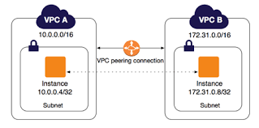

Benefits of VPC Network Peering

VPC Network Peering has the following benefits:
- Network Latency: Connectivity that uses only internal addresses provides lower latency than connectivity that uses external addresses.
- Network Security: Service owners do not need to have their services exposed to the public Internet and deal with its associated risks.
- Network Cost: Google Cloud charges egress bandwidth pricing for networks using external IP addresses to communicate even if the traffic is within the same zone. If however, the networks are peered they can use internal IP addresses to communicate and save on those egress costs. Regular network pricing still applies to all traffic.
How VPC Peering Works: Multi-VPC Connections

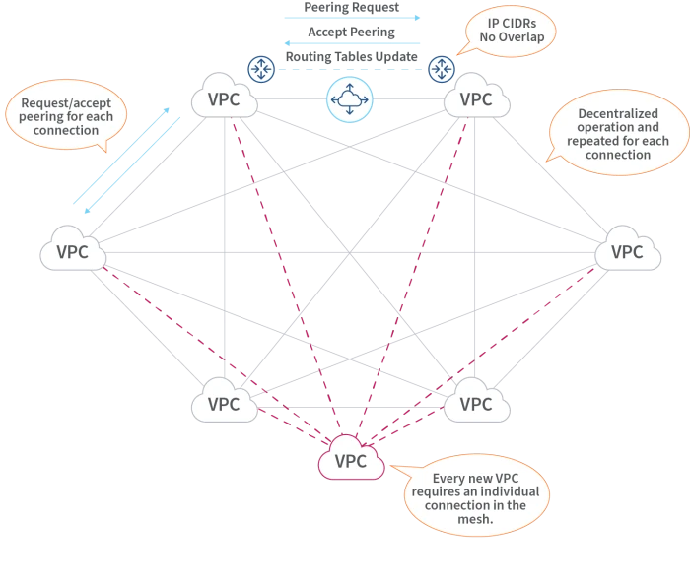

Transit Gatway :-
AWS Transit Gateway helps you design and implement networks at scale by acting as a cloud router. As your network grows, the complexity of managing incremental connections can slow you down. AWS Transit Gateway connects VPCs and on-premises networks through a central hub.
AWS Transit Gateway connects your Amazon Virtual Private Clouds (VPCs) and on-premises networks through a central hub. This connection simplifies your network and puts an end to complex peering relationships. Transit Gateway acts as a highly scalable cloud router—each new connection is made only once.
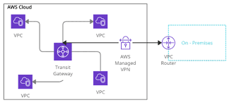

Benefits of Transit Gateway:-
1. Easier connectivity: It serves as a cloud router, simplifying network architecture. The complexity of managing incremental connections does not slow you down as your network grows. When developing global applications, you can use inter-Region peering to connect AWS Transit Gateways.
2. Better visibility and control: You can easily monitor your Amazon VPCs and edge connections from a single console with AWS Transit Gateway Network Manager. AWS Transit Gateway Network Manager, which is integrated with popular SD-WAN devices, assists you in quickly identifying issues and responding to events on your global network.
3. Improved security: Traffic between an Amazon VPC and an AWS Transit Gateway is routed through the AWS global private network and is not accessible to the general public. AWS Transit Gateway inter-Region peering encrypts all traffic and eliminates the possibility of a single point of failure or bandwidth bottleneck. This aids in the prevention of distributed denial of service (DDoS) attacks and other common exploits.
4. Flexible multicast: AWS Transit Gateway multicast support allows the same content to be distributed to multiple specific destinations. This eliminates the need for costly on-premises multicast networks and reduces the bandwidth required for high-throughput applications like video conferencing, media streaming, and teleconferencing.

Why should we use Transit Gateway?

Without AWS Transit Gateway: Scale increases complexity. Within each VPC, you must maintain routing tables and connect to each onsite location using separate network gateways.

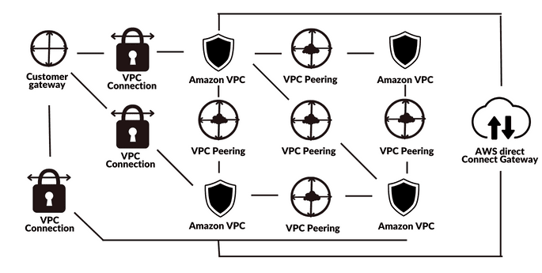
With AWS Transit Gateway:Your network is more efficient and scalable. AWS Transit Gateway routes all traffic to and from each VPC or VPN, and you can manage and monitor it all from a single location.

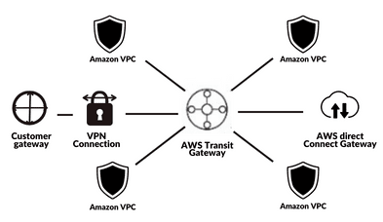
Transit Gateway Vs VPC Peering :
